Monday  Reading Comprehension | Tuesday  Introduction to Superheroes | Wednesday  Creating a villain | Thursday  Writing play script | Friday  Producing superhero choice poem

Metacognitive strategies  The learning sequence in the next column is spilt into a number of sessions. Each session will have a main metacognitive focus but will often include other elements as well. The metacognitive strategies are listed below. | 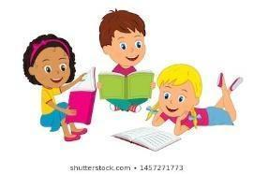  Literacy Tasks (offline and online)  Main learning objectives:  - To understand the purpose of non-chronological reports.  - To understand how to use subordinate clauses and conjunctions in writing.  Desired outcome: To write a non-chronological report on microorganisms.  This unit of writing will be developed over two weeks.  Written work to be submitted by Friday 22nd October 2021.
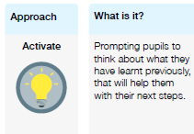 | Tuesday Work can all be found on the PowerPoint  What you will being learning about: 1. Features of a superhero text.  Part 1  - What is a superhero? Someone who has extraordinary powers  - Fights day-to-day crime  - Also has an archenemy who wants to take over the world  - Usually wears a costume or disguise.  - What are common traits a hero has?  - Why do we have superheroes? Role models to their audiences. For entertainment and fantasy.  - Superpowers as a feature. What superpowers can we list as a class?  - Think about the hero costume – discuss the colours and what they represent/mean – link back to the art topic on colour theory.  - Main activity: Children to design their superhero for their own superhero story.  - Plenary – ask children to compare their superhero designs with their partners – give constructive criticism if needed.  ------------------------------------------------------------------------------------------------------------------------------------------------------------------------------  Wednesday  - What is a superhero? What did we discuss yesterday?  - Let’s share some of our superheroes. What makes them special? What makes them a good hero? Why?  - Today we are going to be creating a villain that will be our antagonist. (an antagonist opposes someone or something).  - What are some famous villains we know of? What makes them a good villain? Why?  - Activity: design your villain. Think about their backstory – why are they a villain? What do they want? How will they achieve it?  Thursday  - Today we will be learning about play scripts.  - What is a play script? What is the purpose of a play script?  - What are the features of a play script? Name of characters, colons, stage directions, narration.  - Activity 1: fill in the missing play script.  - Activity 2: Write your own play script with your partner to preform (choose out of your superheroes and villains).  Extension: create a short comic strip to illustrate the play script.  Friday  - Superhero poems – what is a poem? What are the features of a narrative poem?  - Why do poets like to rhyme? What is a rhyme scheme?  - Read through the examples on the PP. Discuss the features and what the class like and dislike about the poem.  - Create examples of personification and similes on whiteboards.  - Activity: produce a poem about their superheroes.  - Plenary: share each child’s poems with the class. Children can publish them on paper for the classroom display.
Pl
