Metacognitive strategies  The learning sequence in the next two columns is spilt into a number of sessions. Each session will have a main metacognitive focus but will often include other elements as well. The metacognitive strategies are listed below. | Maths Tasks (offline and online)
Main learning objective: To find the volume of shapes

Assessment activities to by submitted by: Friday 10th September, 2021
Complete the Mymaths activities.
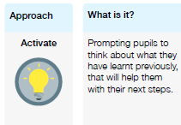 | Lesson One:  Monday  Show children dienes and counters as representatives and what they mean/represent (have a flip PV chart available for LA if necessary)  Use PP for section below  Introduce PV chart (use term ones and units) – get ch to really understand it from thousandths to 10 million (but concentrate most on whole numbers). State we break numbers into groups of 3 in order to read them. Get ch to practise breaking numbers into 3 and reading them aloud. Do this a lot as many struggle. Read some large numbers out and ch write down what you have said, ch make mistakes with this.  Children complete questions stated on pp from the four different WR sheets  Alternative  Power Maths Text book 6A p.8 – read and work on together. Then p.11  plenary  Put a digit in the missing spaces to make the statement correct.  4,62 __ ,645 $<$ 4,623,64 __  Is there more than one option? Can you find them all?  Watch the following video on ‘numbers to 10,000’ using the links below:  https://whiterosemaths.com/homelearning/year-6/week-1/  Go on to Mymaths and complete the following activities:  - Place Value beyond 10,000  - Working with thousands  Lesson Two:  Tuesday –  Maths pack 1 – place value – get ch to identify value of digits, read the numbers etc talk about odd and even etc  Using counting stick count forwards and backwards in different amounts to and from different starting points.  Maths pack 1 – number line (notice difference between pv chart and number line) – using big numbers get ch to identify missing numbers (don’t do negative numbers yet). Do some add and subtract on the number lines too with a range of different starting and ending numbers with different intervals (go beyond the scales too to make ch aware it is ongoing and challenge them crossing 100s, 1000s etc).  Now follow Tuesday on PP consolidating number line and activity questions too.  Extension  Activity – using grid ch add and subtract 10, 100, 1000, 10,000 etc to given numbers  Alternative  Power maths practice book 6A – p. 6-8  Could use headstart yr 5 p. 16  Plenary  Dora has the number 824,650  She subtracts forty thousand from her number.  She thinks her new number is 820,650  Is she correct?  Explain how you know.  Watch the following video on ‘numbers to 100,000’ using the links below:  https://whiterosemaths.com/homelearning/year-6/week-1/  Go on to Mymaths and complete the following activities:  - Place Value hundreds thousands  Lesson Three:  Wednesday –  Using pv counters identify how many ones in 100, ones in 10,000 etc. how many 1,000 in 100,000 etc. 10,000 in 1,000,000 etc.  Give ch a 6-digit number and they have to state the counters that would be used to make it. only allowed, 1, 10, 100, 1,000, 10,000, 100,000 and 1,000,000 counters. Are there different ways of doing this?  Ask the ch what number is 15 ones? 65 tens? What about 32 ones + 28 tens?  Now go through the pp consolidating part whole model and given questions too  Alternative  Maths no problem workbook p.3-4  Power maths practice book 6A p. 10, 11, 12, 13, 14  EXTENSION  Give ch 5 different numbers (different digits too – 4 digit number, 5 digit and 6 digit etc) – in their books they partition it and then state what counters would be used (same counters as above)  3,457 / 10,098 / 57,901 / 210,671 / 958,210  Plenary:  0 3 3 5 5 6 7  Use the digit cards above and statements to work out my number.  - The ten thousands and hundreds have the same digit.  - The hundred thousand digit is double the tens digit.  - It is a six-digit number.  - It is less than six hundred and fifty-five thousand.  Is this the only possible solution?  Watch the following video on ‘numbers to a million’ using the links below:  https://whiterosemaths.com/homelearning/year-6/week-1/  Complete the document titled ‘Numbers to a million’  Lesson Four:  Thursday – warm up – double and half numbers up to 100 – give strategy of partitioning numbers to help  Maths pack 1 – vertical drag stick – create a range of number lines again and ch to plot stated whole numbers on the number line correctly as a class (not negative numbers yet). Do lots of practice with this with different intervals too.  Introduce measures – reading scales – how reading a number is important – ch complete tasks on identifying where the dial is on different scales with different intervals.  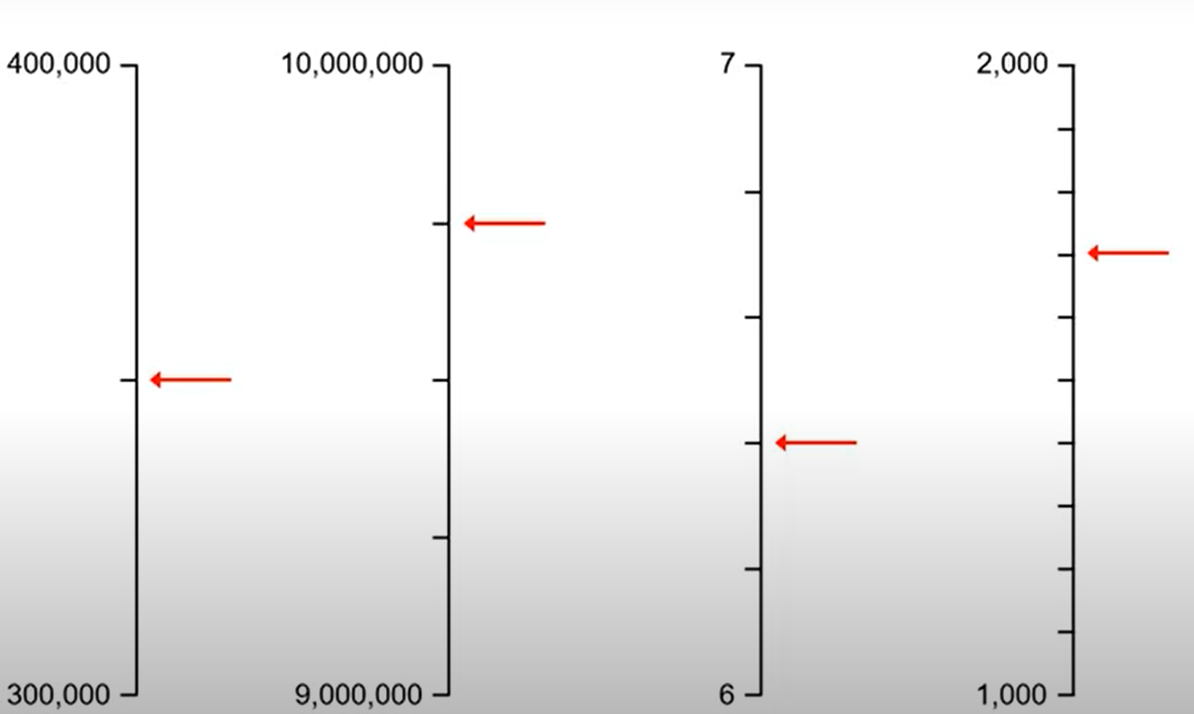  Now use the pp to consolidate number lines and complete given activities too.  Teaching measures – mass – use a range of whole number intervals for ch to practise identifying missing numbers on scales.  Extension  Extra sheet on missing numbers on a number line  And  Ch complete I see reasoning task on plotting numbers on given number lines  Watch the following video on ‘numbers to 10 million’ using the links below:  https://whiterosemaths.com/homelearning/year-6/week-1/  Complete the document titled ‘Numbers to 10 million’  Lesson five:  Apply PV knowledge to reasoning questions from the week – see pp.  Extension  WR reasoning questions from separate pp  Complete the document titled ‘number lines’
