Monday  Grammar starter  Features of a newspaper report | Tuesday  Grammar starter  Planning newspaper reports | Wednesday  Grammar starter  Writing newspaper report | Thursday  Edit and publish newspaper report | Friday  Reading comprehension

Metacognitive strategies  The learning sequence in the next column is spilt into a number of sessions. Each session will have a main metacognitive focus but will often include other elements as well. The metacognitive strategies are listed below. | 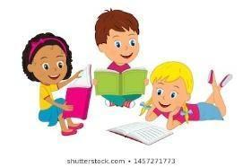  Literacy Tasks (offline and online)  Main learning objectives:  - To understand how to use features of a newspaper article in writing.  - To understand how to write to inform.  Desired outcome: To write newspaper article based on Lewis Carroll’s nonsense poem, The Jabberwocky.  This unit of writing will be developed over two weeks.  Written work to be submitted by Friday 14th January 2022.
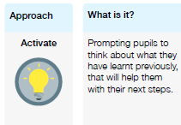 | Lesson 1 Work can all be found on the PowerPoint  What you will being learning about: Newspaper articles.  Grammar starter –  - What is a newspaper report?  - What are the features?  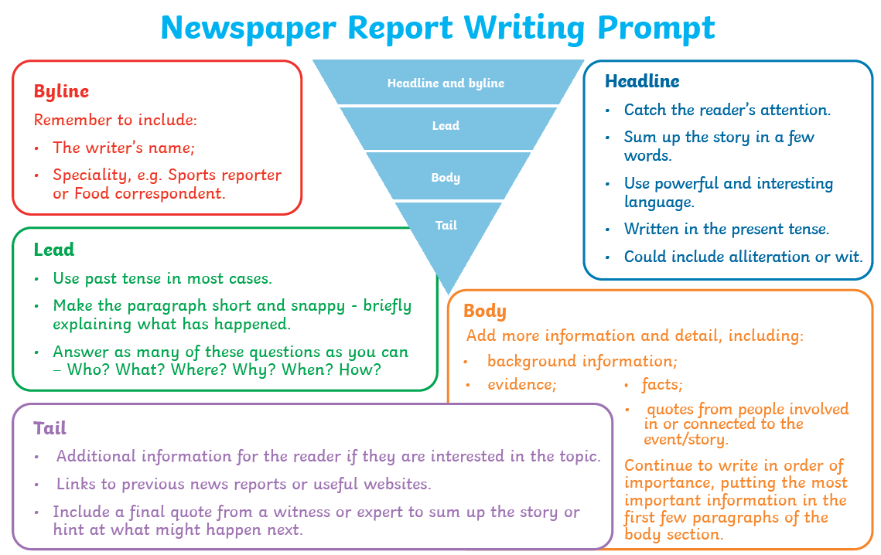  - Let’s look at the example to identify the features used and understand how they have been used in writing (on pp).  - Activity: Using a colour key, identify the features used in the example newspaper.  - Extension: in rough work books, think of ways you could write a news article based on The Jabberwocky.  Lesson 2  - Grammar starter on pp.  - Recap the features of a newspaper report – what are they? Why do we use them?  - Summarise the story of the Jabberwocky.  - How could we report on the tale of the Jabberwocky?  - Activity: Begin planning newspaper report.  - Extension: draft up first copy in rough work books.  Lesson 3 and 4 – writing and publishing  - Grammar starter on pp.  - How could we report on the tale of the Jabberwocky?  - Read through an example newspaper report as a class.  - 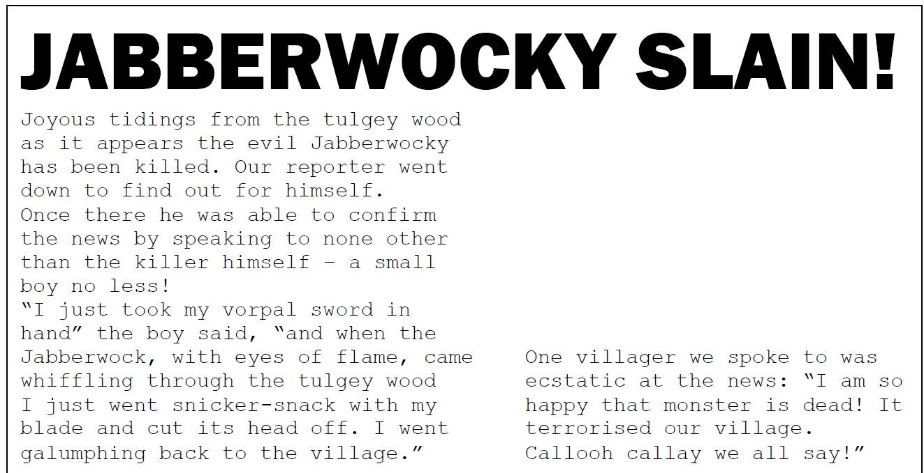  - What is missing from this? What have they included? What could be added to make it better?  - Activity: Begin writing newspaper report.  - When finished (on Thursday), edit with a partner and go through it to look for ways to improve and uplevel work. When happy with the writing, publish into top copy books.
Pl
