Wednesday  Grammar starter  Introduction to The Jabberwocky Poem | Thursday  Grammar starter  Portmanteau words | Friday  Reading comprehension

Metacognitive strategies  The learning sequence in the next column is spilt into a number of sessions. Each session will have a main metacognitive focus but will often include other elements as well. The metacognitive strategies are listed below. | 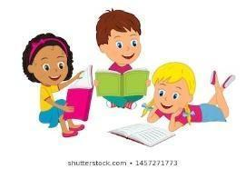  Literacy Tasks (offline and online)  Main learning objectives:  - To understand how language is used in poems  - To understand how to use features of a newspaper article in writing.  - To understand how to write to inform.  Desired outcome: To write newspaper article based on Lewis Carroll’s nonsense poem, The Jabberwocky.  This unit of writing will be developed over two weeks.  Written work to be submitted by Friday 7th January 2022.
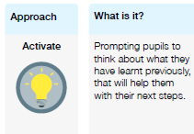 | Lesson 1 Work can all be found on the PowerPoint  What you will being learning about: Poetry.  Grammar starter –  - Grammar starter – test based questions  - Introduce the poem to the class and watch the following video: https://www.youtube.com/watch?v=GLQos7-Vq8M  - Read The Jabberwocky as a class – break down the poem into different sections and summarise what happens in each part.  - Watch the following videos about performing poetry: Michael Rosen’s tips https://www.youtube.com/watch?v=RvV23xoZRkI Joseph Coelho’s tips https://www.youtube.com/watch?v=wFCcbFtd6Zo  - Discuss the best tips – which are most helpful? Why?  - Children to put themselves into groups. Perform the poetry whilst role playing to tell the story to the audience (the class).  Lesson 2  - Discuss what happened in the poem – what kind of poem do they think this is?  - This is a nonsense poem narrating the tale about the killing of a creature named the Jabberwock.  - What words sound like nonsense? Slithy – lithe and slimy. Lithe – active. Chortle – chuckle and snort (Lewis Carroll coined the term for this word in 1855 when this was written). Galumph – Gallop and triumph. Bandersnatch is a swift beast.  - These are called portmanteau word, also called blend: a word that results from blending two or more words, or parts of words, such that the portmanteau word expresses some combination of the meaning of its parts.  - Try combing the following words just like Lewis Carroll did:  Break frolic Bounce Crash Run Scream See Shop  Race Cough shriek Compete Shout wiggle Skip Sleep  Cower Dance Devour flounder Scurry Solve Study Trample  lope Whisper Groan Implode  - Activity: Use your own portmanteau words in a short piece of writing! This can be a narrative poem or in a paragraph.
Pl
