Metacognitive strategies  The learning sequence in the next two columns is spilt into a number of sessions. Each session will have a main metacognitive focus but will often include other elements as well. The metacognitive strategies are listed below. | Maths Tasks (offline and online)
Main learning objective: recap previous learning and apply knowledge

Assessment activities to by submitted by: Thursday 16th December, 2021
Complete the Mymaths activities.
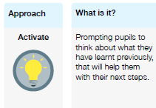 | During the week, complete as many activities on Mymaths as you can that are due (at least 2 each day). Try to focus on activities that you know you need to practise.  If you finish them all, please complete maths activities allocated to you on Abacus (via Bugclub)  Finally, if you have time, please complete sessions on TTrockstars and Numbots to improve your number fluency.
