Monday  Grammar starter  Letter writing | Tuesday  Grammar starter  Letter writing | Wednesday  Grammar starter  Letter writing editing | Thursday  Publishing letters | Friday  Reading Comprehension

Metacognitive strategies  The learning sequence in the next column is spilt into a number of sessions. Each session will have a main metacognitive focus but will often include other elements as well. The metacognitive strategies are listed below. | Literacy Tasks (offline and online)  Main learning objectives:  - To understand the purpose of letter writing.  - To understand how to use the passive voice in writing.  Desired outcome: To write a letter from the perspective of an elf working at Santa’s workshop.  This unit of writing will be developed over one week.  Written work to be submitted by Friday 10th December 2021.
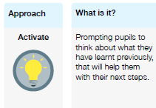 | Lesson 1 Work can all be found on the PowerPoint  What you will being learning about: Letters.  Grammar starter – passive voice.  - What are the features of a letter?  - 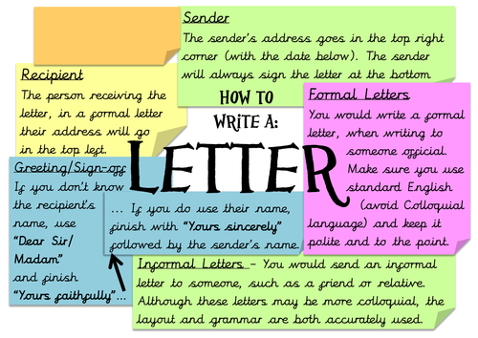  - Children will receive a letter written to Santa from children in year 2. They will be writing a letter back to the child but acting as though they are one of Santa’s helpful elves.  - Each child is to read the given letter and pick out key questions asked.  - Children are to think of possible answers they could write in response.  - Activity: mindmap questions and possible answers as though they are an elf helping Santa respond to children’s letters.  Lesson 2  - Grammar starter – test based questions on the use of passive voice.  - Recap yesterday’s learning and work – what kind of questions were asked by children? Are there any common questions?  - Read through the examples to inspire ideas and to set the tone of voice – they are friendly, helpful elves who are responding back to the child as Santa is very busy preparing for Christmas.  - On the board, write down possible answers that children could write in response.  - Remind children that they cannot promise anything to the child they are writing to.  - Activity: Children begin drafting their letter in response to the child, writing as though they are an elf helping Santa.  Lesson 3  - Grammar starter – test based questions on the pp on passive voice.  - Allow children to read aloud their letters to share ideas with the class and expectations.  - Children to edit their letter with a partner – what could they add? Do their sentences make sense? Could they add anything more?  - Does it sound like it is written from an elf? How could they make it more friendly? Could it be funny?  - Activity: Edit their letters with a partner.  Lesson 4  - Children are to spend the lesson typing up their final copies of the letters.  - There are templates they can use or they can create their own using clipart and the editing features found on Microsoft Word.  - They are to decorate the letters with clipart images of snowflakes or candy canes – anything that relates to Christmas or Santa.  - Activity: Children to publish their work using laptops and Microsoft Word.
Pl
