What adjectives could we use to describe her?

What is Lady Macbeth thinking?

[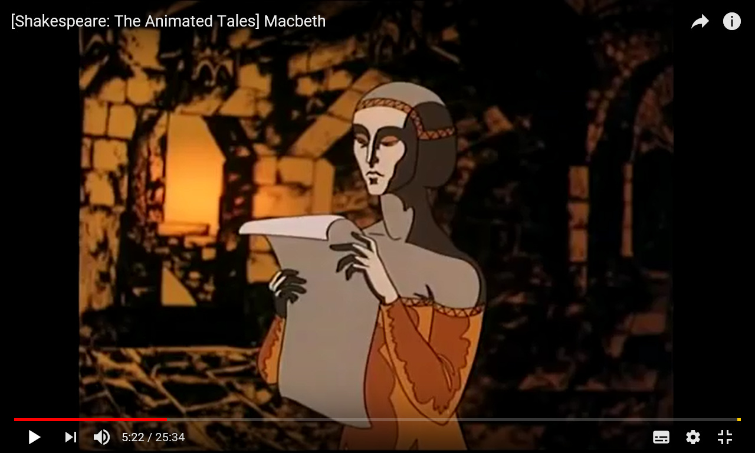](https://www.youtube.com/watch?v=qfnUq2_0FOY)

How does she compare with her husband?

How does she talk, move look?

What adjectives could we use to describe her?

How does she compare with her husband?