Metacognitive strategies  The learning sequence in the next two columns is spilt into a number of sessions. Each session will have a main metacognitive focus but will often include other elements as well. The metacognitive strategies are listed below. | English (offline and online) | Maths (offline and online)
 | Main learning objective:  English:  To explore the characters in greater depth. | Main learning objective:  Maths: Rounding to 10, 100 & 1000
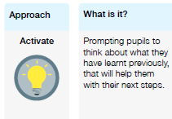 | Monday English – on paper.  PART ONE  Recap on the story of the Midnight Fox and remember what we know about Tom. Think about what we know about Tom’s mum and dad.  PART TWO  Role play the different characters to explore their thoughts and feelings.  Tuesday English:  To write a character description  Part one  Recap on the characters; what we know about them.  Write a simple sentence about one of the characters on paper. Think of ways to improve this sentence eg: an adverbial opener.  Part Two  Using your sentences write a character description of Tom or his mum or dad.  Wednesday English: Edit and improve writing.  Take each sentence and look at ways to improve it by using better adjectives, openers and more imaginative language  Thursday English: Write up in in your best writing with all your improvements.  Bring top copy to school when you return  Friday Reading Comprehension:  Log on to Bug club and complete questions on your chosen book. | Monday Maths: Rounding to the nearest 10  Part one  Look at various number line; deduce the numbers which should be at the start and finish of the line and which given number is closest to either the first of last number on the line. What do they notice? It is always a multiple of 10.  Answer the questions on slide 3.  Part two  Children to work through questions 4 to 10 in maths books  Part three  Go through answers with class modelling.  Tuesday: Maths: Round to nearest 100  Part one  Look at number bonds to 100. Practise counting on and back from 100 from different starting points.  Recap on the rounding from yesterday. How will rounding to 100 differ?  Part two  In books complete the questions 1 to 4 from PDF  Part 3  Children complete work sheet PDF  Wednesday Maths: Rounding to10, 100 & 1000  Part One: Recap previous learning and then introduce rounding to 1000.  Go through slides 6-9 as a class with children using whiteboards to record  Part Two: Children complete questions 1 to 4 Go through answers with them.  Go through question 6 as a class.  Part three: Complete questions 7, (8 & 9) in books  Thursday: Recap  Then introduce numbers to 10,000 work through slides. Go through slides 12 & 13 with children working on whiteboards and then they complete questions 1 to 3 on the sheets.  Look at 2 slides on number lines then children to complete questions 4 to 7 in books.  Friday: Rounding to 10,000  Go through slides 1 to 9 then answer questions 1 to 4 in books  Go through slide 13 as a class with children showing their thinking.  Children to answer remaining questions.  Use White Rose videos for lessons and complete worksheets
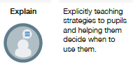
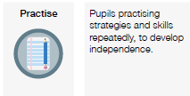
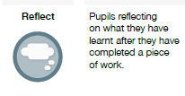
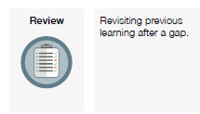

FOUNDATION SUBJECTS:
Please refer to the PowerPoints on the Y5 home learning page for the details of each lesson.
Week 2  In the below column are the thinking steps that your child would make within the classroom. | Foundation (offline and online)  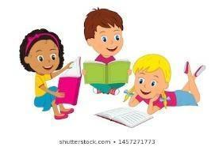 | Foundation (offline and online)  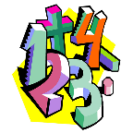
 | Main learning objective:  Science: At home research Space, Earth, Sun & Moon  PSHE: Working as a team  History: To investigate why the Vikings explored so many parts of the world.  To be taught over two lessons in books (Map and writing)  Computing: To be able to use and evaluate the photographic features of a piece of ICT equipment.  To understand what the subject of a photo is. | Main learning objective:  Art: Be able to record shape and space within a still life and be able to explore the various qualities of mark-making  French: Revise classroom instructions. Revise opinions. Learn how to pronounce the ‘j’ phoneme correctly.  RE: To explore the Christian belief in God as Father, Son and Holy Spirit (Trinity), including God as Creator, Jesus as the Son of God, the Spirit acting in the lives of Christians today.  PE: To know where the different parts of the netball court are. To understand the different netball passes. To understand how to mark and signal. To introduce the term footwork.
 | Why did the Vikings come to Britain?  Starter: Think about if you have lived in the same house all your life? Which towns have we lived in? Which countries have we lived in? Which countries do we have relatives in?  Why might people move away from where they were born? Discuss ideas and make notes  Science: Research Space, Earth , Sun & Moon and create a fact file. | Art In sketch books  Sketch various shapes to show how these can be used t create more natural shapes (fruit). Mark various types/strengths/styles (e.g cross hatch etc) marks with a pencil. Use these marks to draw a picture showing light and dark and building on circular technique from last week.  French:  Please refer to power point and work through slides. Classroom instructions PowerPoint.  RE: Why do Christians believe in God?  Think of two reasons why Christians believe in God.  PE: Netball skills of throwing and catching.

