Metacognitive strategies  The learning sequence in the next two columns is spilt into a number of sessions. Each session will have a main metacognitive focus but will often include other elements as well. The metacognitive strategies are listed below. | English (offline and online) | Maths (offline and online)
 | Main learning objective: To be able to write for a variety of purposes  Spellings: Year 5 words – Test first week after half term.  available  average  awkward  bargain  bruise  category  cemetery  committee  communicate  community  Test 23.04.21 | Main learning objectives:  Monday: Translate shapes by comparing one vertex with its image  Tuesday: Translate shapes by translating, e.g. 3 right and 2 down.  Wednesday: translate shapes on axes in the first or all four quadrants  Monday:  Draw a triangle, a quadrilateral or a pentagon on squared paper, Ensure each vertex of the polygon sits on the intersection of a gridline.  Put a spot on one vertex. Put a similar spot on the intersection of gridlines somewhere else on the page. Translate the whole shape using the dotted vertex as a starting point. See the PowerPoint for an example. Repeat with a more complex polygon.  Try using tracing paper to check the answer.  TUESDAY  PART ONE  Show the pupils a polygon and its image that has been translated. Ask them to identify the translation in terms of, e.g. 3 right and 2 down.  PART TWO  Ask the pupils to draw a polygon, as yesterday. Ask them to translate it 3 right and 2 down.  Repeat with another instruction and a more complex polygon. Check answer with tracing paper.  WEDNESDAY  PART ONE  Plot a polygon in the first quadrant. Write down its co-ordinates. Translate it, e.g. 2 left and 3 down. Plot the new shape and write down its co-ordinates.  PART TWO  Repeat this in four quadrants.  Can the pupils plot a shape, read the instructions as to how to much to translate and in which direction (e.g. 1 right and 4 down), then predict the co-ordinates before drawing them.  See ppt for examples.  Tuesday: Exploring reflection.  Warm up: Use the PPT to predict which grid shows the correct reflection.  Talk through methods of reflecting – counting the number of points between to the mirror line. How will we know that it is reflected? How is it the same, How is it different?  Task 1: Reflect along a horizontal or vertical plane  Introduce diagonal plane. Use mirrors to help see what the shape should look like.  Task 2: Reflect along a diagonal plane, using mirrors to aid.  Challenge: Reasoning with pictures.  Wednesday: Translations.  Children should talk through a modelled translation. They should explain what has changed and what has stayed the same. Direction, size, rotation, movements etc. This will help them to isolate the skills needed in order to translate.  Task 1: Describe the translations.  Task 2: Perform a translation.  Task 3: Translation or not. True or false.
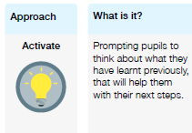 | Please use the PPT where all the links can be found with further detail/instructions for the children to follow.  Monday  Use the All about Diwali ppt to introduce Diwali, what its about and how its celebrated. There is also a link to a video on the ppt.  Then use the Rama and Sita ppt which goes into the story in more detail.  Begin a spider diagram of key events from the story and how Diwali is celebrated.  Tuesday  Look at an example of a Diwali poem.  ACTIVITY – Creating rhyming couplets.  Children to plan/write their Diwali poem.  Wednesday  Write up poem in best. Decorate the page.  Thursday: R jobs and consolidation  Friday – Bank Holiday
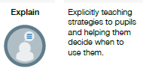
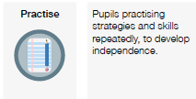
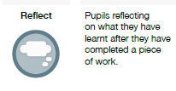
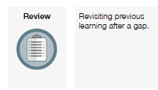

FOUNDATION SUBJECTS:
Please refer to the PowerPoints on the Y5 home learning page for the details of each lesson.
Week 15  In the below column are the thinking steps that your child would make within the classroom. | Foundation (offline and online)  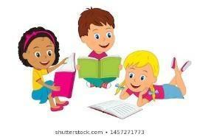 | Foundation (offline and online)  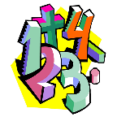
 | Main learning objective:  Geography – To be able to understand geographical features of the land.  DT – To be able to explore the food of different cultures.  ART/DT – To be able to understand the importance of significant landmarks and explore different materials used in construction. | Main learning objective:
 | Geography  Using atlases and the internet children will need to locate India on a map.  Activity 1 – Complete the map activity. Instructions are on the map.  Activity 2 – Watch the following video https://www.bbc.co.uk/bitesize/clips/z4fr87h  Using an atlas complete the atlas challenge cards activity. Children to work in pairs to answer as many of the challenges as possible.  Activity 3 – Using the knowledge from the lesson and or internet if needed children will need to complete the india fact file.  DT  Use the supporting Holi ppt and watch the video on the powerpoint to understand what Holi Festival is.  Children to then follow the Multi-coloured Milk Fudge Recipe to make a traditional sweet. These are to be taken home at the end of the day.  DT/ART  Use the supporting Taj Mahal ppt. Watch the video within the ppt all about the Taj Mahal.  Children to use various materials to recreate the Taj Mahal. Supporting PPT with some ideas for construction. | Additional activities  Dance – Just dance on youtube  https://www.youtube.com/watch?v=WzKA1DcmlOs  Collaborative – Peacock art. PPT for ideas.

