Metacognitive strategies  The learning sequence in the next two columns is spilt into a number of sessions. Each session will have a main metacognitive focus but will often include other elements as well. The metacognitive strategies are listed below. | English (offline and online) | Maths (offline and online)
Main learning objective: To explain and discuss their understanding of what they have read, including through formal presentations and debates, maintaining a focus on the topic and using notes where necessary

Spellings: Year 5 words –
- existence
- explanation
- familiar
- foreign
- forty
- frequently
- government
- guarantee
- harass
- hindrance

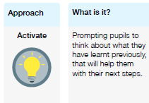 | Monday English  PART ONE  Read the letter to pupils that we send out each year inviting them to apply for the role of school captain.  Read the person specification on the rear of the letter.  What words, phrases, grammar and punctuation make it sound formal?  PART TWO  Make a list of items we could write about in a letter of application for school captain: experiences, personal qualities etc. Make sure that we are addressing the requirements of the person specification with these ideas.  TUESDAY English  PART ONE  Read the unfinished sample letter of application for the school captain role. What features does it possess that make it sound formal? Vocab, grammar, punctuation. How are the paragraphs used to structure the work and make each topic clearer?  PART TWO  Begin to write the letter of application for school captain.  Focus on paragraphing, conjunctions to vary sentence length, sentence demarcation.  WEDNESDAY English  Continue and complete the letter of application.  Focus on formal vocabulary, varying sentence length using conjunctions, grouping related ideas in paragraphs.  THURSDAY English  Make a top copy of the letter of application.  If possible, type it for a more formal appearance.  Friday English  Comprehension activity –  The Audition  PART ONE  Read The Audition silently. While doing so, highlight any unknown vocab.  PART TWO  Re-read The Audition aloud. Discuss any unknown vocab.  Highlight any words or phrases that describe how Lucy is feeling, either about herself or about others. Explain what each word or phrase means. | Monday MATHS  Be able to read timetables and calculate time intervals.  PART ONE  Look at the bus timetable (ONE). Practise answering questions in the form, ‘When does the third bus from ?? arrive at ??’. ‘How long does the second bus from ?? take to get to ??’.  Practise calculating time intervals on an empty number line.  PART TWO  Answer questions from on timetables TWO and THREE  PART THREE  Ask the pupils to devise ONE question based on the stems we’ve used in this lesson. Share with the class and answer them.  TUESDAY MATHS  Be able to read timetables and calculate time intervals. Be able to convert between 12-hr and 24-hr clocks.  PART ONE  Look at the sunrise and sunset table. Find the length of the day on the first day of each month by calculating on an empty number line, as yesterday. Which months have the longest and shortest days? How does this relate to the seasons?  What is the difference between the length of the longest and shortest days?  PART TWO  Convert each time on the timetable from 12-hr to 24-hr time.  Wednesday MATHS  Be able to read timetables and calculate time differences.  PART ONE  Put the pupils into groups of three. Practice converting from 12-hr to 24-hr time using the first few slides of the PPT.  PART TWO  In teams, answer the quiz questions on the PPT.  Thursday MATHS  Be able to add and subtract decimals. Be able to solve problems involving money.  PART ONE  Look at the bank statement. Explain the vocabulary – withdrawal, deposit, balance, direct debits etc.  PART TWO  Calculate how much money the person has spent on (s) bills, (b) direct debits (c) ATM withdrawals.  PART THREE  How much was deposited into the account in total. How much was withdrawn during this period?  Friday MATHS  Be able to solve problems involving money and real-life  Look at the price list for party items.  You have a budget of £50. You would like to throw a party for EIGHT people. What can you buy, ensuring that each person has an equal number of items, AND you cannot spend more than the budget.  NOTE: this can be done either on paper, OR by adding formulae to the spreadsheet in order to model the budget more quickly and flexibly.
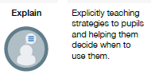
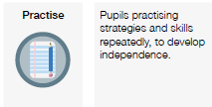
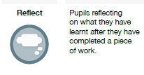
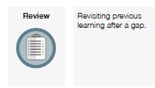

FOUNDATION SUBJECTS:
Please refer to the PowerPoints on the Y5 home learning page for the details of each lesson.
Week 15  In the below column are the thinking steps that your child would make within the classroom. | Foundation (offline and online) | Foundation (offline and online)
 | Main learning objective:  Introduction to World of Work – To understand the purposes and aims of the week.  DT / ART – Georgia O’Keefe (prep for sewing later in term)  Use a different medium to recreate a picture in the style of Georgia O’Keefe such as water colours, pastels, chalks encouraging use of colour.  Art – Linked to theme week. | Main learning objective:  PE – Sports day activities  THEME WEEK PSHE - I can understand there are a variety of routes into different jobs which may match my skills and interests.  THEME WEEK PSHE – What do you want for your future?  TEHEME WEEKE PSHE – What are my qualities and skills?  Music – To be able to understand the features of samba music.
 | DT/Art – Continue with sewing of flowers.  Art – Linked to theme week  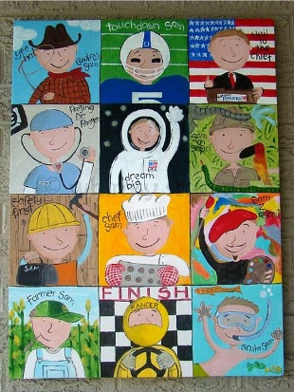  Children to create a self-portrait that shows their career choice for the future.  Introduction to World of Work week.  Use the world of work ppt to introduce the theme week. Discuss as a class different aspirations and goals and potential careers.  Use the following link to explore different jobs and what they do.  https://www.bbc.co.uk/teach/class-clips-video/pshe-ks1-ks2-what-is-my-job/zrdkt39 | P.E – Sports Day  - Hockey stick and ball  - Domes and dishes  - Standing long jump  - Beans bags in hoops  - Mega howlers JM  - Hurdles JM  PSHE  Use the supporting PowerPoint titled The World of Work.  Focus on:  - Personal achievements  - Positive mind set  - Key skills for jobs  - Areas of work  - Routes into careers  - How to develop skills  - Adaptability  PSHE – What do you want for your future?  Discuss with the class what they would like their lives to be like in the future. What will they need to do/be in order to achieve their goals. Where would the like to live, what job would they like to do, what hobbies and interests would they like to have, would they like to travel, what qualities would they like people to see in them.  Complete the activity sheet what do you want for your future?  PSHE – What are my qualities and skills.  Children to complete the activity – what are my quality and skills.  They can then do a drama of an interview process.  Music  Use the supporting ppt to look at the rhythms and features of Samba music. Children will perform as part of an ensemble to recreate the various rhythms.

