Metacognitive strategies  The learning sequence in the next two columns is spilt into a number of sessions. Each session will have a main metacognitive focus but will often include other elements as well. The metacognitive strategies are listed below. | Foundation Tasks (offline and online)
 | To design an Anglo-Saxon purse.
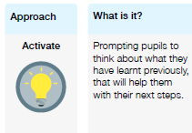 | PE  Can you create your own workout routine? Maybe it will be cardio focused… or maybe you’d like to create a relaxing yoga routine.  PSHE  Super Heroes  Draw a self portrait as a Super Hero (Yellow books)  Write underneath to describe their special power, EG I am Super_Elsie, I am kind to everyone and always helping others.  Art  Continue designing your Anglo Saxon purse. If you have a needle and thread at home, you could practise a running stitch and blanket stitch. These videos will show you how.  Running stitch: https://www.youtube.com/watch?v=i1-B01FB56s  Blanket stitch: https://www.youtube.com/watch?v=S9zegUYdPmg  Superhero Theme Week  Take a look in the superhero folder for some fun activities to complete during theme week!
