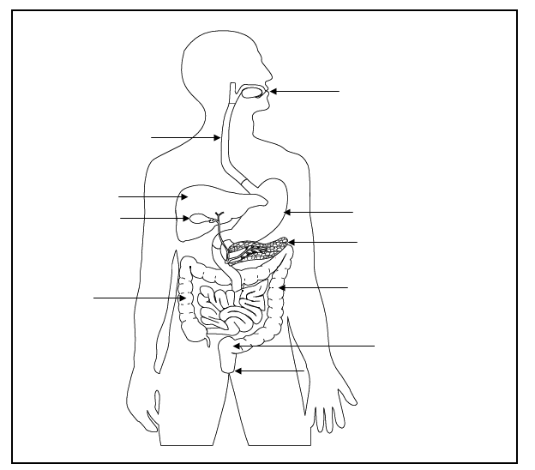

**Challenge :**

Correctly label the diagram- **anus, oesophagus, large intestines, small intestines, stomach, teeth and rectum**

Explain what the teeth do.

Write down what the small and large intestine (colon) take out from the food.

*Can you explain the differences between the small and large intestines?

**Challenge :**

Correctly label the diagram- **anus, oesophagus, large intestines, small intestines, stomach, teeth and rectum**

Explain what the teeth do.

Can you explain the differences between the small and large intestines?





**Challenge :**

Correctly label the diagram- **anus, oesophagus, large intestines, small intestines, stomach, teeth and rectum**

Explain what the teeth do to food.