Metacognitive strategies  The learning sequence in the next two columns is spilt into a number of sessions. Each session will have a main metacognitive focus but will often include other elements as well. The metacognitive strategies are listed below. | Topic Tasks (offline and online)  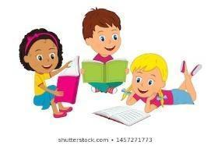
Main learning objective: To consider rules for living, applying ideas from Christians and Humanists. To identify that all sounds are vibrations and understand that volume decreases with distance from the sound source.
Desired outcome: To write a set of rules for living based on 2 religions. To experiment with sound and use the results to draw conclusions.
Assessment activities to by submitted by: See below
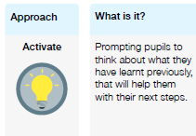 | RE: Refer to the Humanism PPT and The 10 commandments to understand codes of living. How are they similar/different? Imagine you were living on a desert island and were in charge of creating a code of conduct for living. What would your rules be? Write them down. I would like to see this please.  Science 1: Watch: https://classroom.thenational.academy/lessons/what-is-sound-chh30r  Use the science – vibrations word document to experiment (with available resources in your home!) Record what happens in all of the different given scenarios.  Science 2: Watch: https://www.bbc.co.uk/bitesize/topics/zgffr82/articles/zqtdpbk  Use the science investigation word document. IF you have access to an app, download a decibel meter. If not, just do your best to listen carefully to the sounds. Drop a stack of books (bound together) from the same height and move further away each time from the dropped books. What do you notice? Complete the worksheet (if possible, if not write a prediction and conclusion for what you think will happen and what happened). I’d like to see this please.  French: Use the food opinions PPT. Try to pronounce the words accurately and try writing your own sentence.  P.E. Begin to learn the big festive dance: https://youtu.be/mUmlCoX3ie4 or access here: https://drive.google.com/file/d/1EVbaDXr2mx4lNrKyrbtCQdNlG9GafzEL/view  Music: Begin to write some lyrics for a ‘clean school rap’. Try to make them rhyme and think of rhythmic patterns e.g:  I’m an Engayne kid and I keep my school clean,  When I see people litter, I think they’re really mean…etc.  PSHE: Log onto votes for schools and cast your vote after viewing the KS2 PPT (online)  Art: Have a go at making your own decoration for a Christmas tree.
