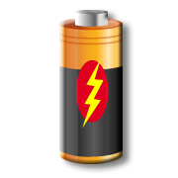MC900038677[1]

Must: understand that a battery is a source of electricity

Should: say whether an appliance uses mains, a battery or both

Could: give reasons why

mains

both

battery