Metacognitive strategies  The learning sequence in the next two columns is split into a number of sessions. Each session will have a main metacognitive focus but will often include other elements as well. The metacognitive strategies are listed below. | Transition week tasks and activities. (offline and online)  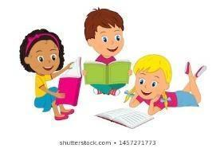
Main learning objectives:
I can think of some questions I would like to ask my new Year 2 teacher.
I can share my experiences, likes and preferences.
I can concentrate and take turns in games.
This week in school, the children will be completing transition activities and getting to know their new building, classroom environment, class teachers and new friends. Here are the tasks and activities for you to enjoy completing at home.
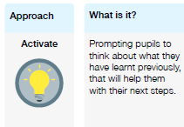 | Monday  Session 1 – Reading  Read and share a book on Bug club. Can you answer the bug’s questions by clicking on the picture of the bugs head?  Session 2 – Getting to know you  At school in this session, the children will be introducing themselves to each other, asking questions and finding out information about their new classmates. See if you can answer these questions ready to share when back in class.  When is your birthday? Do you have brothers or sisters?  Do you have a pet?  Where is your favourite place to visit?  What is your favourite food?  Draw a picture of yourself in your Engayne uniform.  Session 3 – What will make your new classroom a lovely place to be?  Can you think of ways you can help make your new classroom a wonderful place to be?  Have a look at the picture cards below to help with your ideas. Choose something that you think you can do and will be able to show your new teacher. Are you a good listener, are you always kind to others, are you a tidying superstar or do you work hard and always try your best.  When you have chosen something, make your own poster using some important words and decorate with a picture or a colourful border.  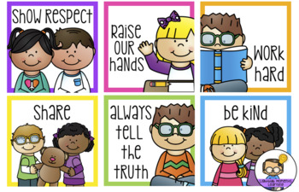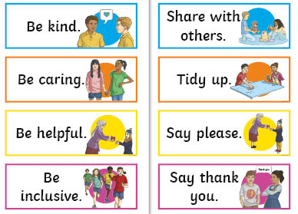  Session 4 – All about me rainbow  In this session, the children are going to find out a little bit more about each other, sharing things they like to do and about their personalities. You are going to write sentences and then colour the rainbow, you can use crayons, colouring pencils or make a rainbow collage. The rainbow picture can be found in the Y2 web page.  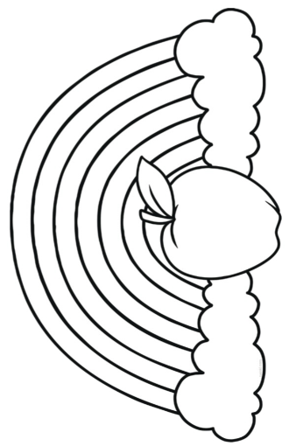  In the apple write, My name is…  In one cloud write, I like to…  In the other cloud write, I am…  Session 5 – Snakes and ladders  Learn how to play Snakes and ladders, practise taking turns and counting carefully. The Snakes and ladders board and counters can be found in the Y2 web page. You will also need a dice.  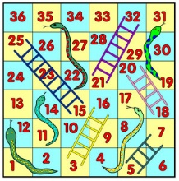  Roll the dice, move your counter along that number of spaces. If you are lucky and land on a ladder, you can climb up the ladder to your new square but beware if you land on a snake’s head you must slide down to the bottom of its tail!  Tuesday  Session 1 – The day the crayons quit  In Year 1 you would have read the book ‘The Day the Crayons Quit’ by Drew Daywalt. To remind yourself of the story, watch and listen to this lovely read alive version.  https://www.youtube.com/watch?v=489micE6eHU  Now we would like you to write a poem about your favourite colour. Look at the poems below to help with your ideas. There is a template worksheet on the Y2 web page.  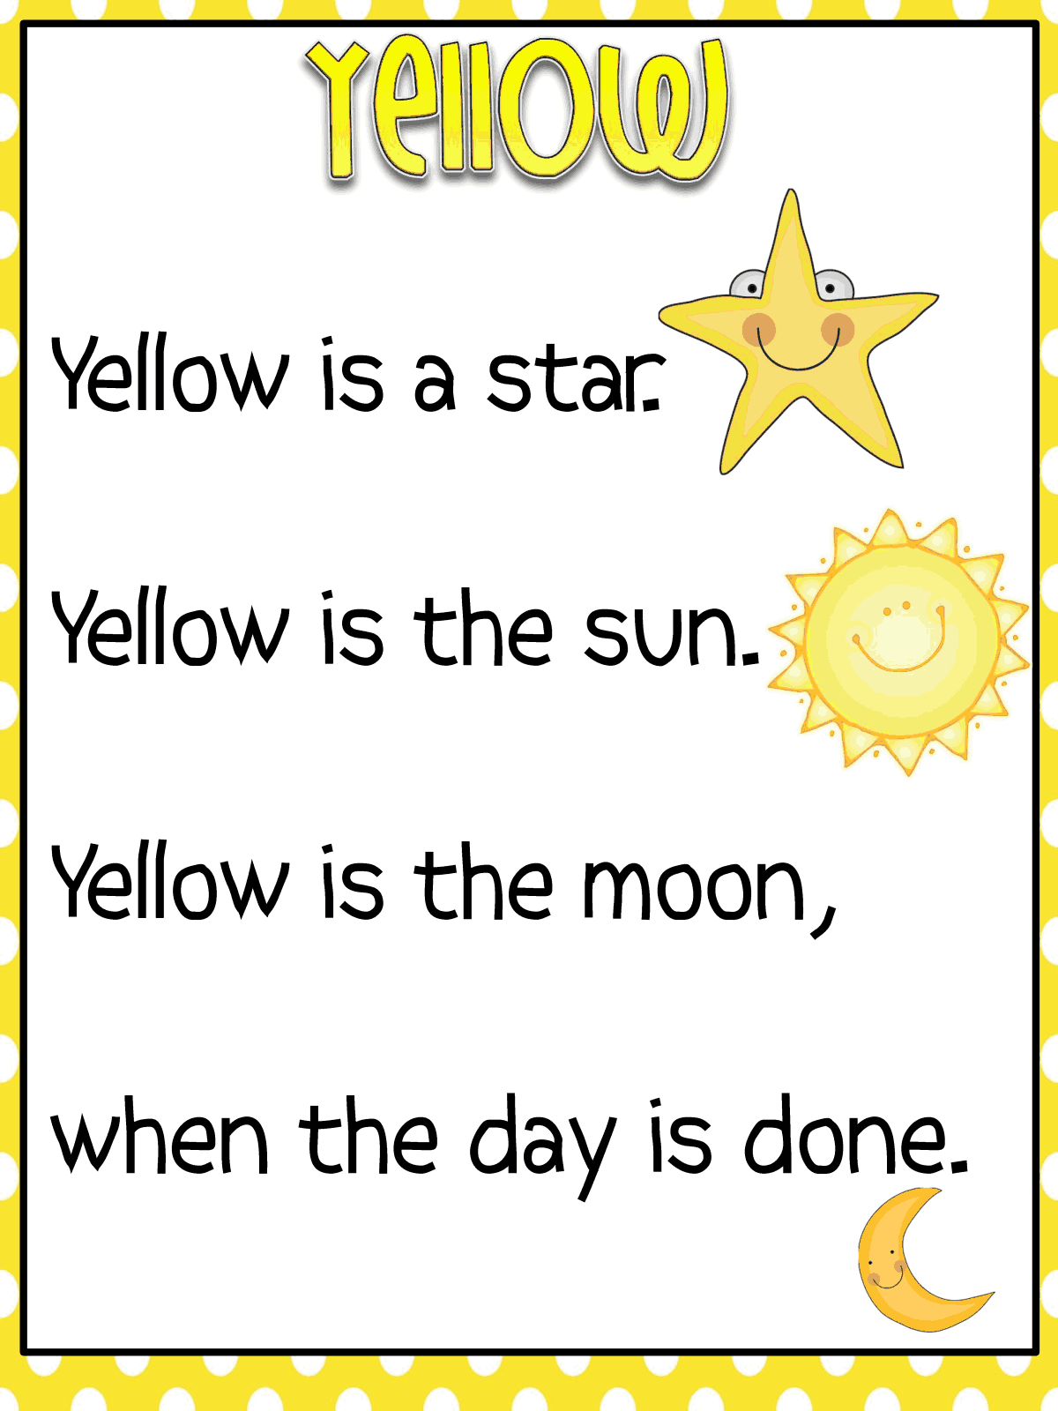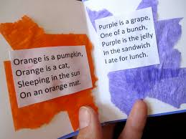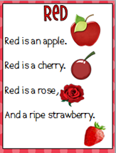  Session 2 – Scavenger hunt  In this session, the children will be using their senses to find different things in their surrounding area. Using the worksheet, My five senses scavenger hunt see what you can find around your house or in your garden.  Can you remember the five senses and which parts of the body you use for them ? Look at the picture below to help you.  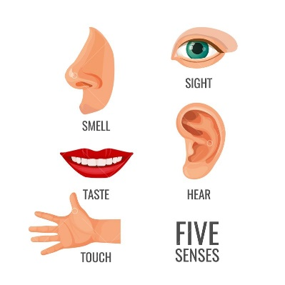  Session 3 – Free choice art activity  Time to get creative, using whatever craft and art materials you have, use your imagination to make a picture of your choice.  Session 4 – Eye Spy  Play a game of eye spy. Look carefully at all the pictures and think about what sounds the objects beginning with. An eye spy picture board can be found in the Y2 web page.  Wednesday  Session 1 – Reading  Read and share a book on Bug club. Can you answer the bug’s questions by clicking on the picture of the bugs head?  Session 2 – ‘Hear my story’ Tate London Project  In this session, we would like to find out about your connections to other countries, people, languages, places and favourite things. Can you think about the answers to these questions -  Where and who are you connected to? (countries, places, people)  What foods do you like?  What do you enjoy doing?  What books do you love?  What makes you happy?  You can draw or cut out pictures to represent these things to make a colourful collage.  Session 3 – Dominoes  Learn how to play dominoes, practice taking turns and number matching skills. Play with a partner, take turns and see if you can match the number of dots on their dominoe, if you can not you miss a turn. There is a printable set of dominoes on the Y2 web page.  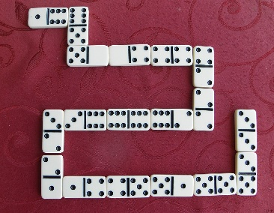  Session 4 – Free Choice play  Express yourself free choice activity. Would you like to do something creative, build, dance to music, play a favourite game or spend some time outside?  Session 5 – Watch a story film  End of term treat; watch the film Room on a Broom by Julia Donaldson.  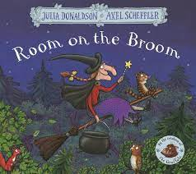  The story is about a kind witch who invites a surprising collection of animals to join her on her broom, much to the frustration of her cat. The gang saves the witch from a fearsome dragon, and to say thank you she rewards them with a magnificent new broom, which has room for everyone.  https://www.bbc.co.uk/iplayer/episode/p0102qfj/room-on-the-broom
