Metacognitive strategies  The learning sequence in the next two columns is split into a number of sessions. Each session will have a main metacognitive focus but will often include other elements as well. The metacognitive strategies are listed below. | 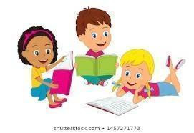  Transition Tasks (offline and online)  You can do these lessons in any order
Main learning objective: I can think of some questions I would like to ask my new Year 1 teacher.
This week in school we would be completing transition activities and getting to know our new class teachers. See if you can complete these tasks at home. We can’t wait to see you soon!
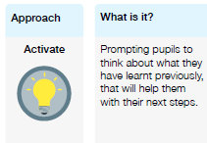 | 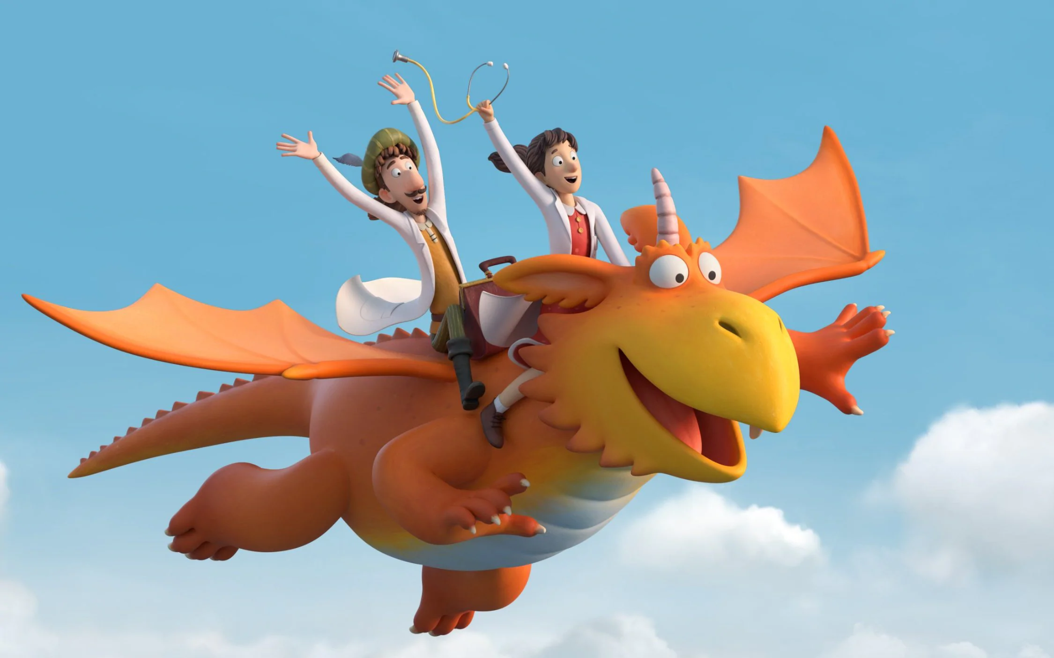  MONDAY - ZOG  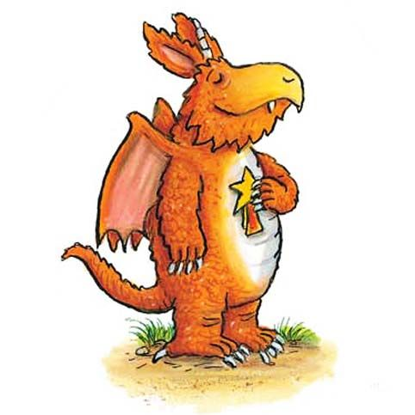  In Reception you would have read the book ‘Zog’ by Julia Davidson. To remind yourself of the story, watch this lovely video which is a TV adaptation of the book: https://www.bbc.co.uk/iplayer/episode/b0bwdw8y/zog  In the story, Zog never gives up even if he finds something tricky. After working so hard he receives a golden star.  What things are you good at and what things do you find tricky? Can you colour in a picture of Zog on our webpage and add labels around the outside.  Are you good at maths, spelling, reading? Do you find writing or swimming a bit tricky? Even adults find things tricky sometimes!  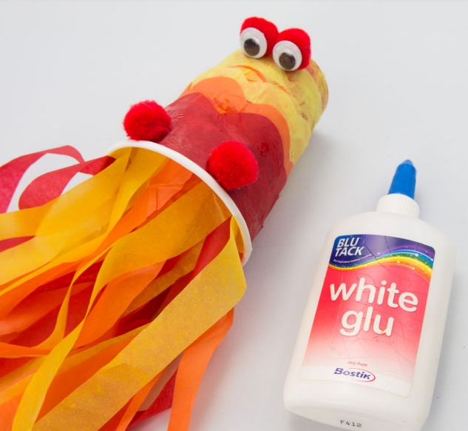  Extra tasks:  - Can you make a model of Zog (or another dragon) using craft materials?  - Using construction toys such as lego, can you build a castle to protect a princess from the dragons?  - Princess Pearl doesn't like silly frilly dresses. Can you design some new clothes that she might like?  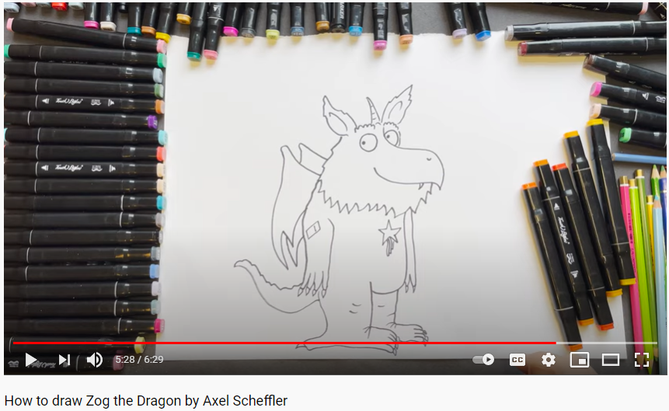  - Complete the ‘Directions Challenge Sheet’ on our website. Can you help Zog find his way back to the dragon school?  HOW TO DRAW ZOG  The illustrator of ‘Zog’, Axel Scheffler has got a handy tutorial for how to draw Zog. Can you follow along at home? Click to watch here.  We have added some additional activities that your child may enjoy at home on our webpage. Please see the ZOG folder.  TUESDAY - ‘Hear my story’  As part of our ongoing project with TATE London, we would like you to think about what makes you unique! In school we will be making a class collage. If you are at home, see if you can speak to an adult and answer these questions:  Where are you connected to? (countries, places, people) Do you have any hobbies? Do you go to any clubs outside of school? What foods do you like? What books do you love?  Do you speak any different languages? Do you have any special talents? Do you have any pets? What makes you happy? What makes you sad?  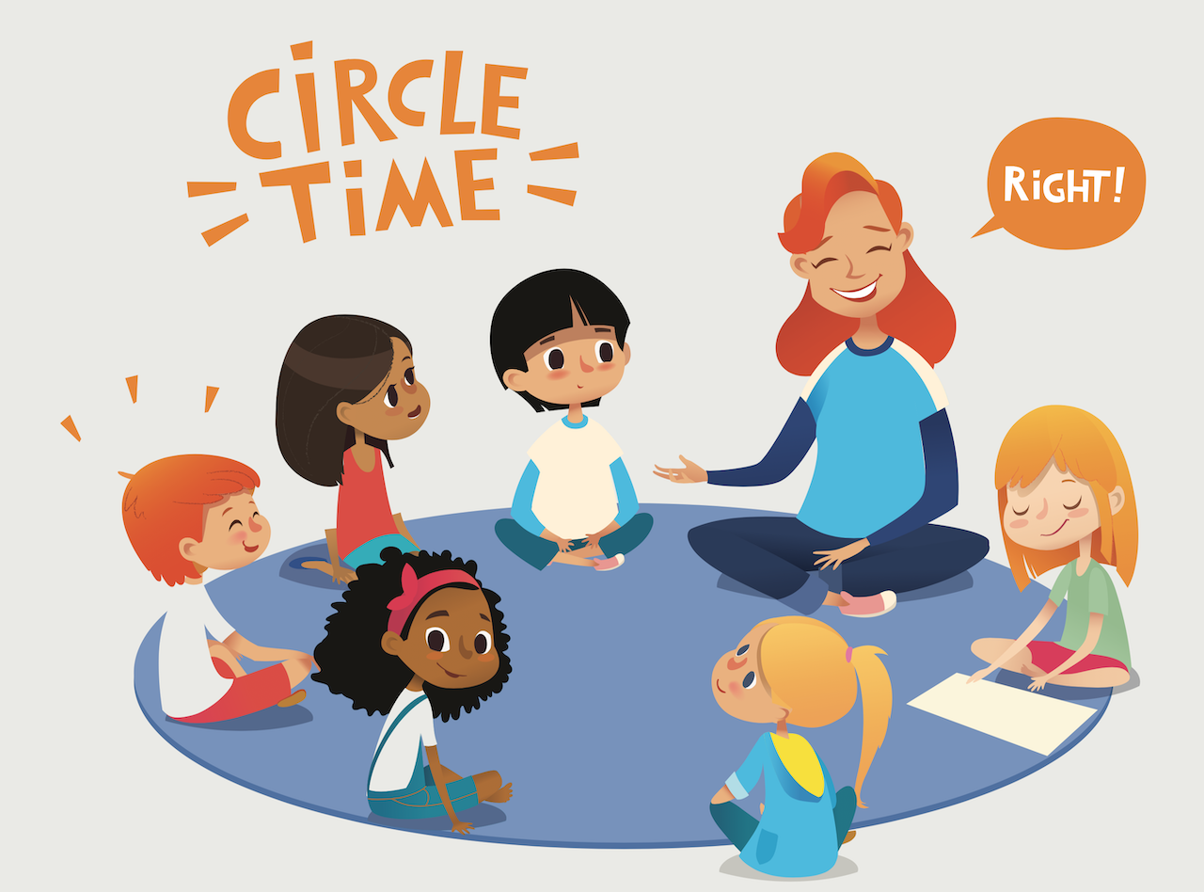  WEDNESDAY - Getting to know Year 1  Have a think about how you can get to know your new teacher and classroom. Talk with your grown up about how things might be different and how things change as we get older and move up a year group. Luckily you know all your friends in your class and you'll be staying together as you move into Year 1.  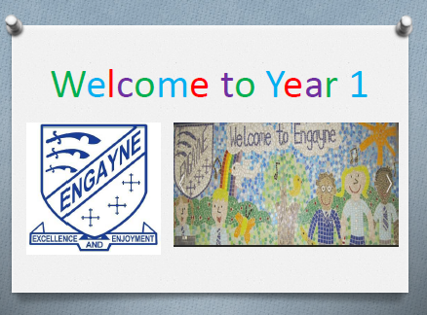  Take a look at our ‘Transition to Year 1’ powerpoint on the webpage to find out more about what happens in Year 1.  In class we will be playing some circle games and having fun outside under the Year 1 canopy. If you’re at home you could join in with one of our favourite year 1 games:  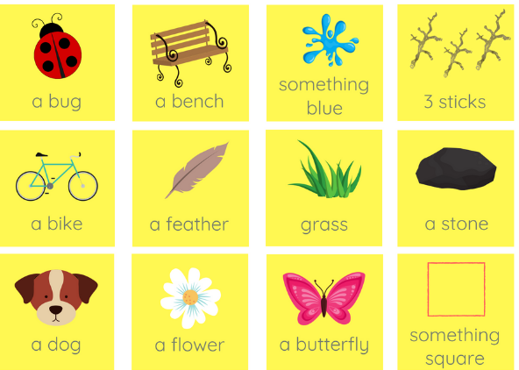  SUPER SUMMER SCAVENGER HUNT!  See if you can find any of these things near where you live, or from your window. Some are going to be tricky to find!
