n

i

d

m

[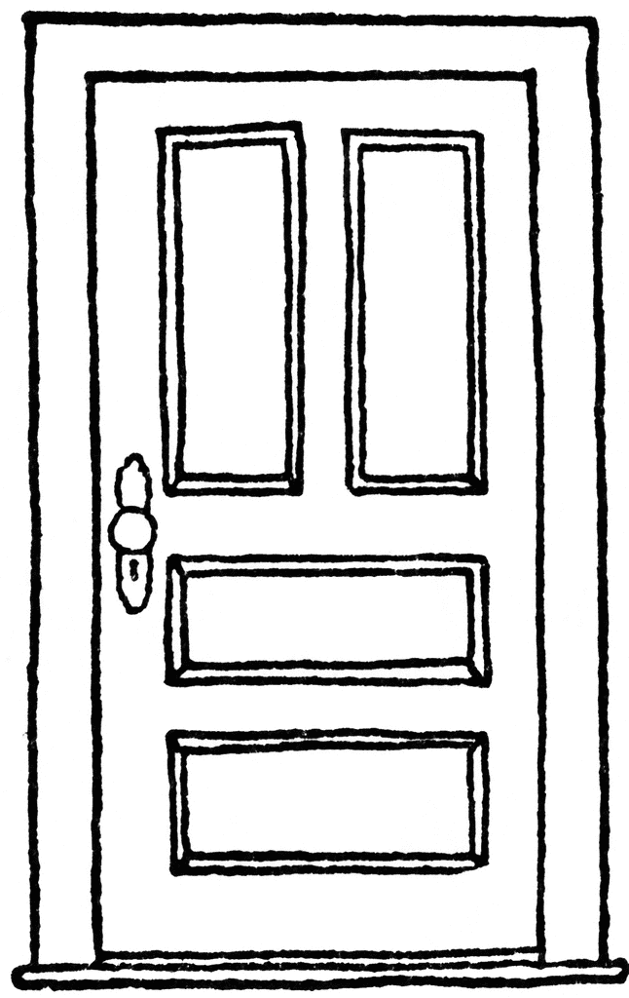](http://www.google.co.uk/url?sa=i&rct=j&q=&esrc=s&source=images&cd=&cad=rja&uact=8&ved=0ahUKEwjg2ObhyuDWAhUQLlAKHdz-Ch8QjRwIBw&url=http://www.clipartpanda.com/categories/door-clipart-black-and-white&psig=AOvVaw12s4YKYAF-qTOd66Jodo9O&ust=1507536904250357)

[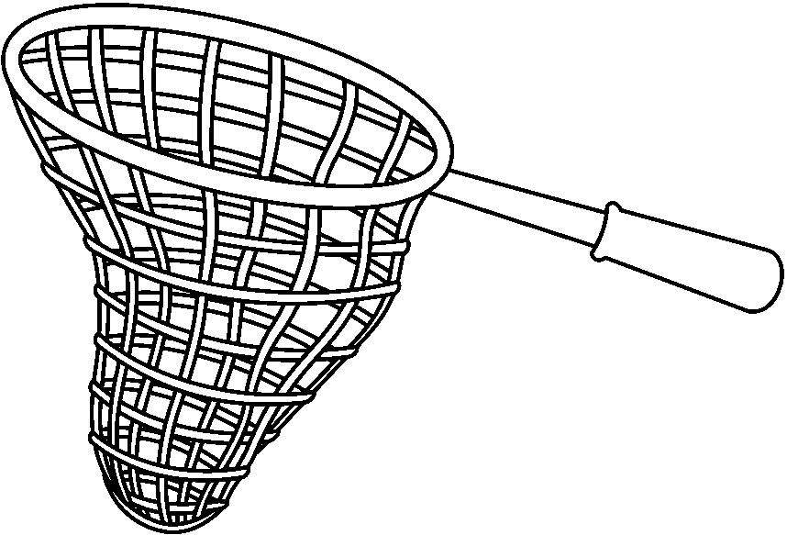](http://www.google.co.uk/url?sa=i&rct=j&q=&esrc=s&source=images&cd=&cad=rja&uact=8&ved=0ahUKEwjk8660yuDWAhVLIlAKHegiAfMQjRwIBw&url=http://clipart-library.com/clipart/8TGb5oa7c.htm&psig=AOvVaw2o1dzv1Gt5fsvQXeFIqiNi&ust=1507536810507885)

[](http://www.google.co.uk/url?sa=i&rct=j&q=&esrc=s&source=images&cd=&cad=rja&uact=8&ved=0ahUKEwiAnJjSyuDWAhWFIVAKHb99D8gQjRwIBw&url=http://www.clipartpanda.com/categories/mouse-clip-art-black-and-white&psig=AOvVaw2UEF0bxeuxKIodI4PN1JSF&ust=1507536875374938)

[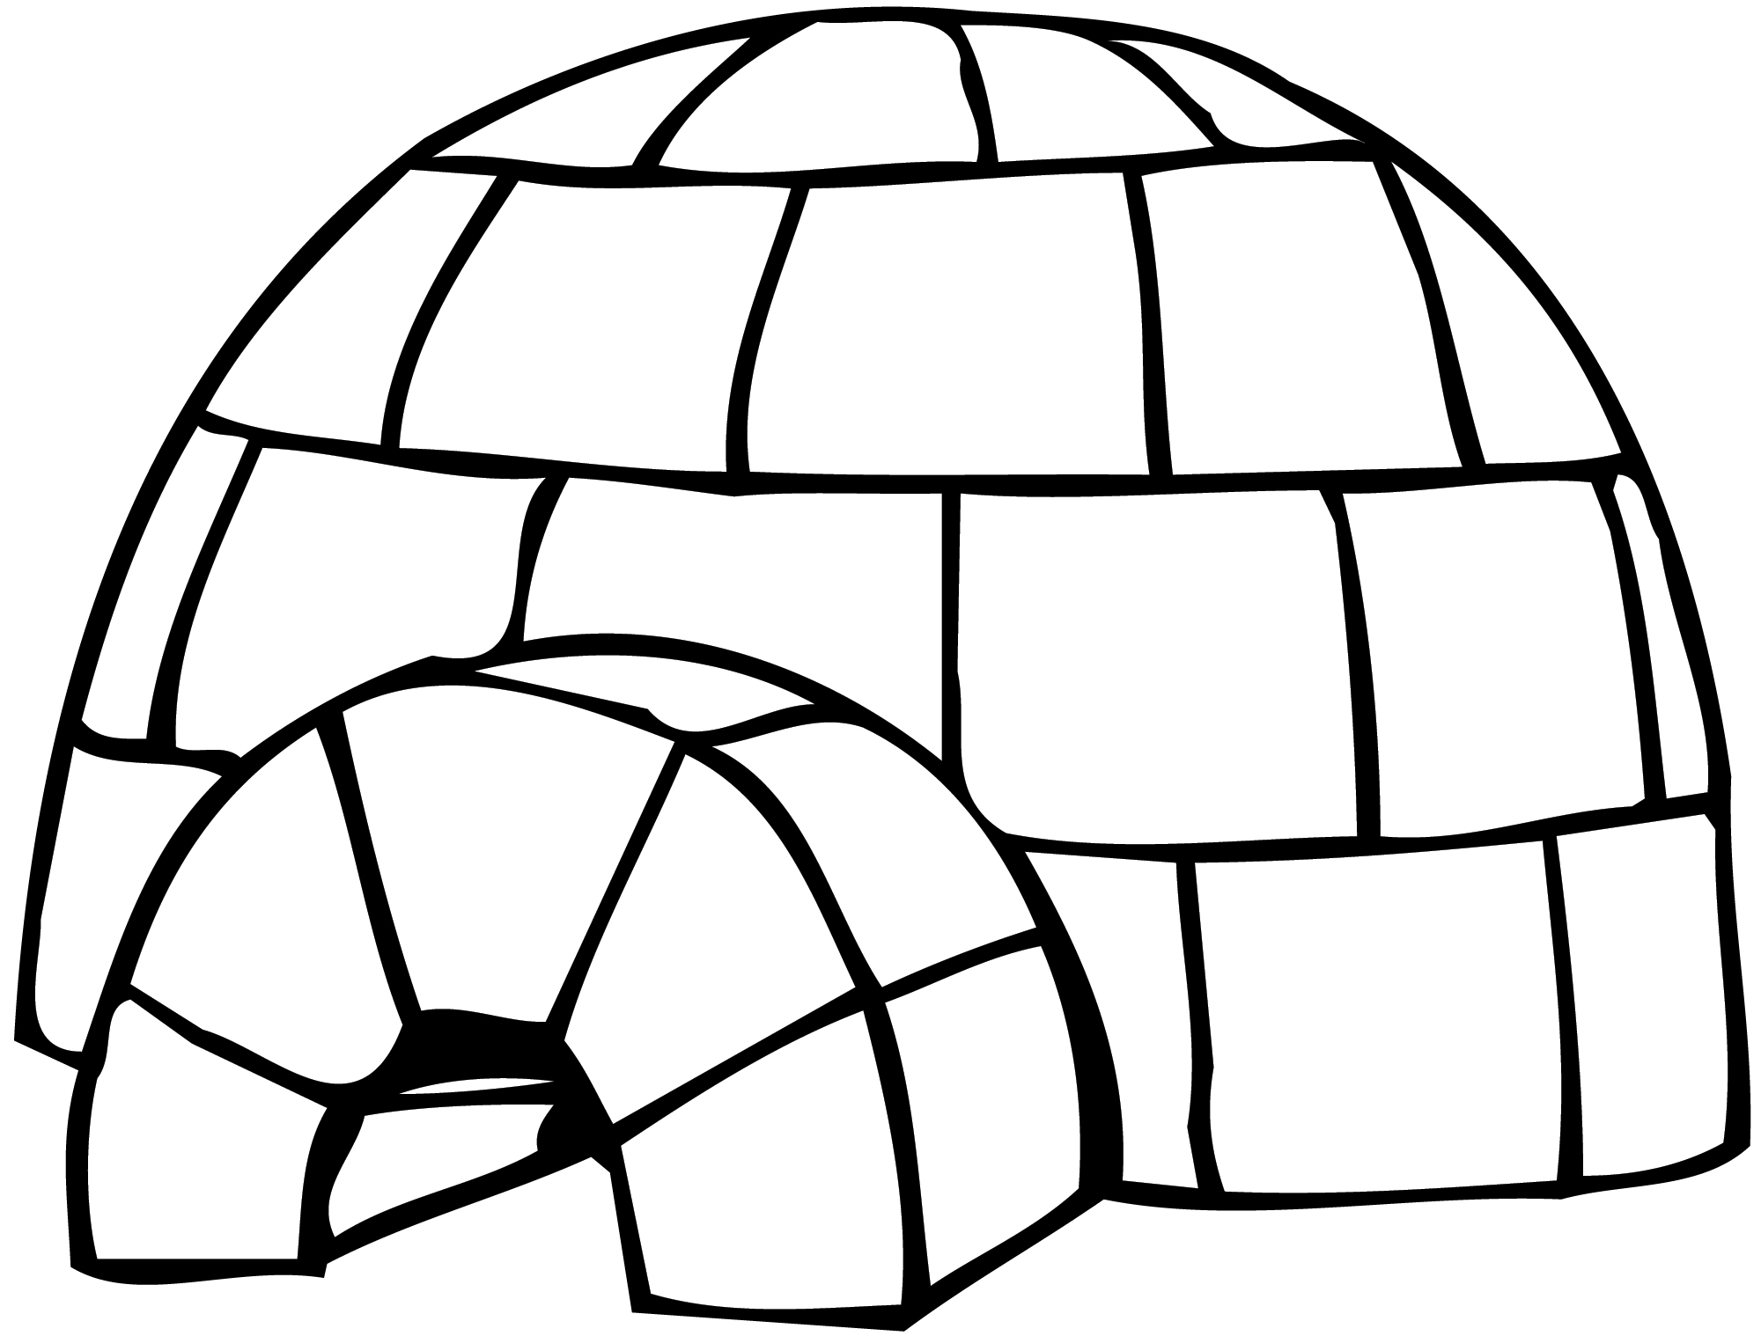](http://www.google.co.uk/url?sa=i&rct=j&q=&esrc=s&source=images&cd=&cad=rja&uact=8&ved=0ahUKEwjDpOqgyuDWAhUGK1AKHXhdAAcQjRwIBw&url=http://www.clipartpanda.com/categories/igloo-clipart-black-and-white&psig=AOvVaw1T5kFD43Tv4QD5u_dzcYmJ&ust=1507536772102755)